Lab #1: Measurements and Graphical Analysis

By: Nathan Capule

Purpose Statement (s): Given “disks” of different radii, determine the relationship between the mass and radius of the disks through graphical method. In using graphical method, we will learn about linearization and the use of it to create a mathematical model.

1. Write a brief outline of the procedure you will use to collect data. What data

would you need to collect?

I will fold the disk until I can clearly see the thickness on the ruler, then I would divide the thickness of the folded disk by the amount of times I folded the disk. This would help me get the thickness of the disks, for the radius I will fold the disk in half and measure the length of the semicircle created, then I will decide that length by 2 to get the radii. Finally, I would place each disk on a scale to find the mass in grams.

2. Answer these Qs right after your procedure. What is the precision of the meterstick I used? Explain how you know this based on the data I provided.

The ruler I used was precise to the millimeter so I measured to the nearest tenth of a millimeter. I know that the precision of the ruler that I used was to the millimeter because there are 10 equidistant ticks between centimeters and one tenth of a centimeter is a millimeter.

3. Create a data table. Make sure you give it a title and make sure you label each column. Include the units you will use. Include a column with calculated values that will “linearize” your graph.

| Disk Number | Height (cm) | Radius (cm) | Mass (g) |  | Radius^2 (cm) |
| --- | --- | --- | --- | --- | --- |
| 1 | 0.003125 cm | 6.70 cm | 0.67 g |  | 44.89 cm |
| 2 | 0.003125 cm | 5.10 cm | 0.37 g |  | 26.01 cm |
| 3 | 0.003125 cm | 4.00 cm | 0.21 g |  | 16.00 cm |
| 4 | 0.003125 cm | 3.10 cm | 0.14 g |  | 9.61 cm |
| 5 | 0.003125 cm | 2.35 cm | 0.08 g |  | 5.5225 cm |

4. Graph #1: Non-linear graph showing the relationship between mass of disks (y axis) and radius of disks (x axis), assuming uniform thickness. Make this graph using your graphing calculator or online calculator and insert the picture of it in your document. Is this a LINEAR or NONLINEAR graph? You can provide a mathematical formula underneath your graph (just get it from the calculator.)

Radius versus Mass

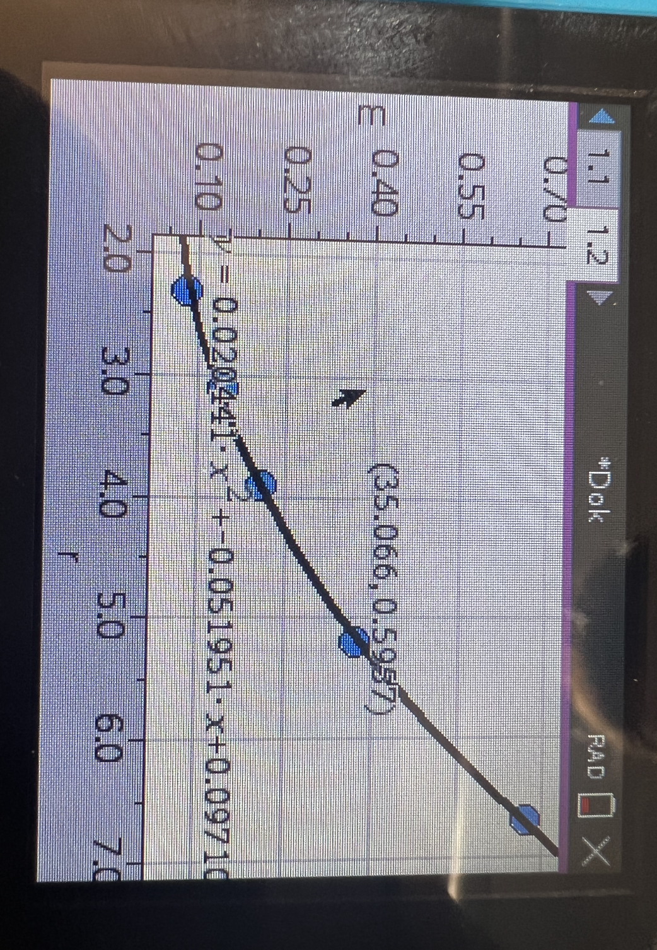

This is a nonlinear graph, you can see that it is nonlinear because the slope of the line is changing as the x value changes.

In our class, linear graphs provide the best relationships for us.

5. Graph #2: Linearized graph. Make this second graph using your calculator as well. How will you “linearize” your graph? Apply a line of best fit to your graph. Insert this graph. Again, using your calculator, get a mathematical formula…

Radius^2 Versus Mass

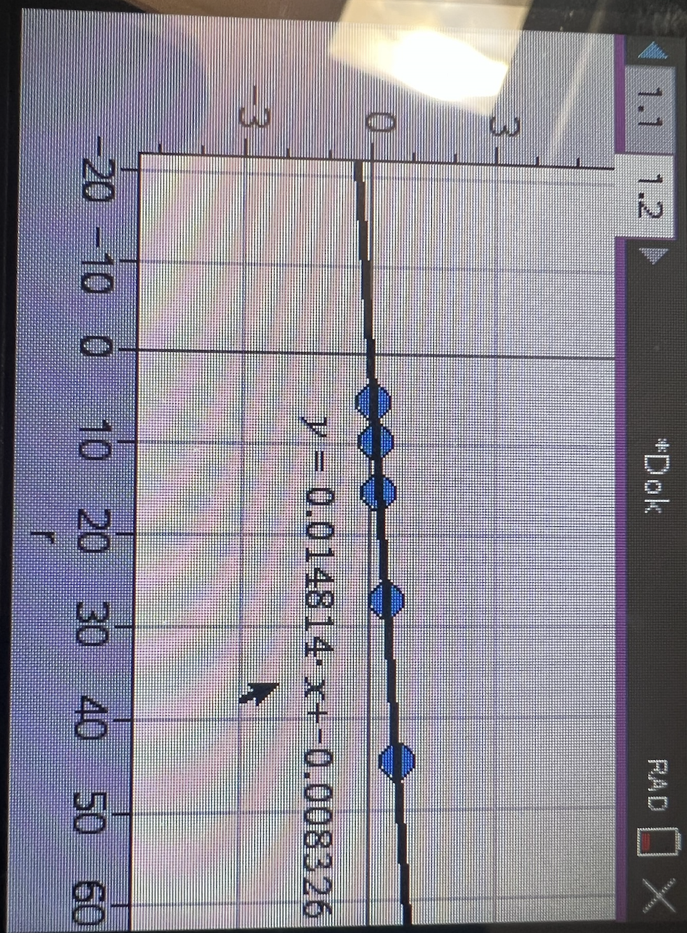

6. Below your Graph #2, What is the equation for your line of best fit in the form y = slope · x + intercept?

y=0.014814x -0.008326

Mass=Rho⋅Pi⋅height⋅Radius^2

The 5 Analysis Questions were answered on paper:

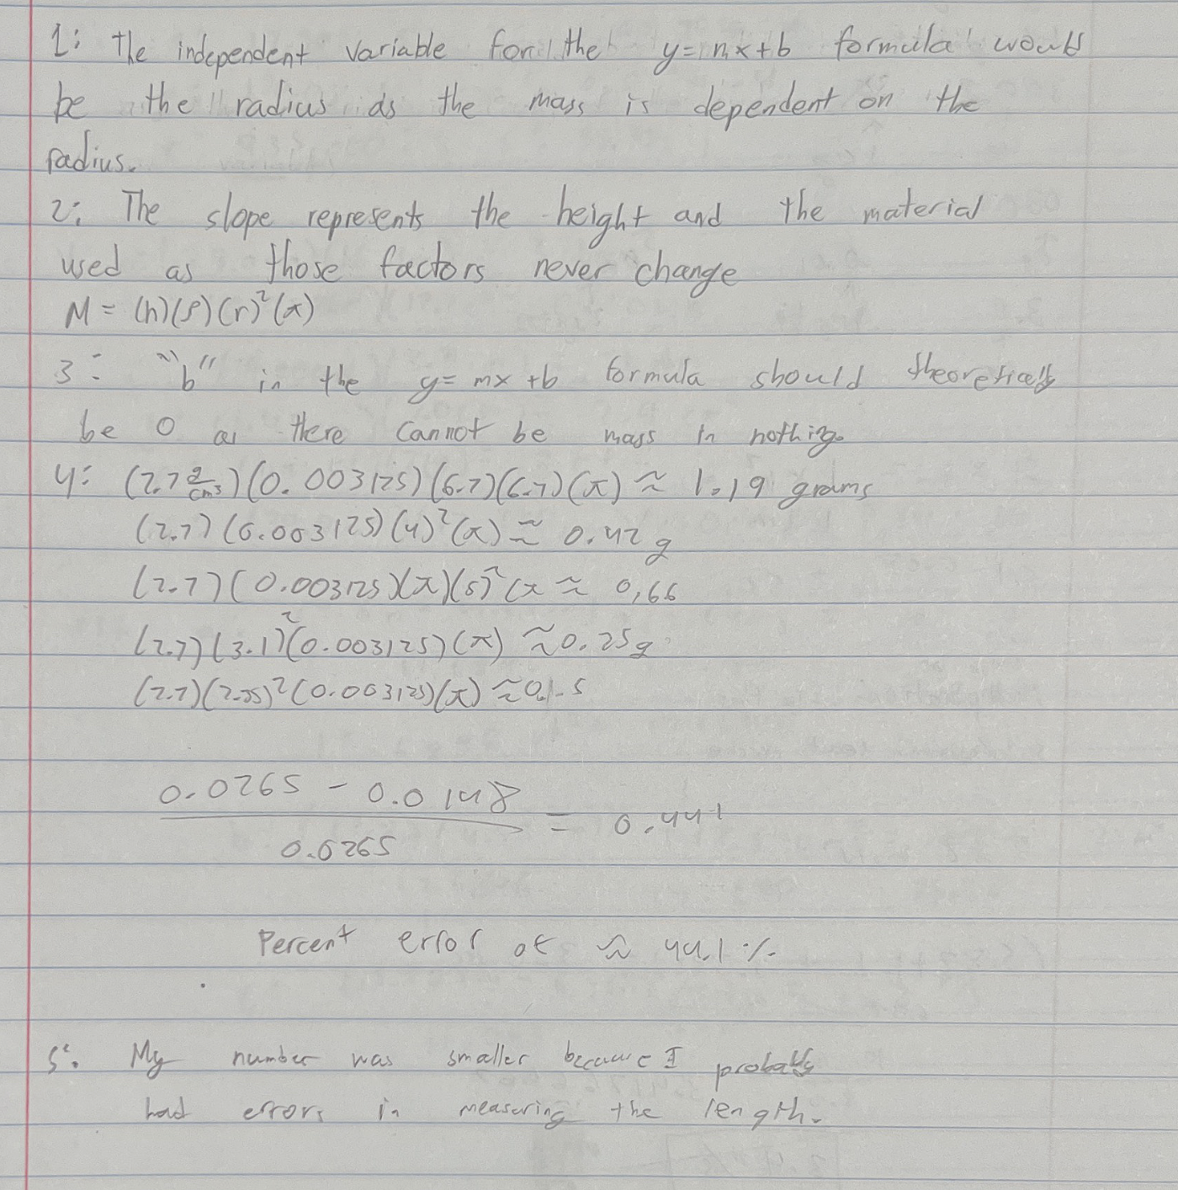

Synthesis Questions

1. In this experiment, if we had used disks with a greater thickness, would the slope of your best fit line have been different? Would your experimental value for density be the same? Explain.

The slope would have increased if the disks had a larger thickness but the experimental density would have been the same. This is because as the height increases, the mass would also increase meaning that the density would be the same.

2. How would your graph of m versus r2 be different if you had used disks of the same thickness, but made out of steel? Draw a second line on your m versus r2 plot that represents disks made of steel.

The graph would be much steeper as the density of steel is much greater than that of aluminum. The red line represents the line for disks made of steel, I got this by dividing the slope of the aluminum plates by 2.7 (the density of aluminum) and multiplying it by 7.85 (the density of steel).



3. Another group of students has acquired data for the exact same experiment; however, their disks are made of an unknown material that they are trying to determine. The group's m versus r2 data produced a line of best fit with slope equal to 122 kg/m2. Each disk they measured had the same 0.5 cm thickness. Calculate the density of the unknown material and use the table below to help determine what material their disks are made of.

Mass=Rho⋅Pi⋅height⋅Radius^2 Slope is rho pi and height, divide slope by height and pi to find rho which is density. 122kg/m^2=0.122g/m^2=12.2g/cm^2 12.2g/cm^2/0.5pi=7.77 so the material is iron.

